**Clauses in SQL:**

There are generally five kinds of SQL Clauses in MySQL Server. They are listed as follows:

* WHERE Clause

* ORDER BY clause

* HAVING Clause

* LIMIT Clause

* GROUP BY Clause

**1. SQL WHERE Clause**

In MySQL, we use the SQL SELECT statement to select data from a table in the database. Here, the WHERE clause allows filtering certain records that exactly match a specified condition. Thus, it helps us to fetch only the necessary data from the database that satisfies the given expressional conditions. The WHERE clause is used with SELECT statement as well as with UPDATE, DELETE type statements and aggregate functions to restrict the no. of records to be retrieved by the table. We can also use logical or comparison operators such as LIKE,<,>,=, etc. with WHERE clause to fulfill certain conditions.

**Query:**

**SYNTAX:**

SELECT Column1,….ColumnN From Table_name WHERE [condition];

**For example, we are considering a table named Books as the demo:**



**Query:**

SELECT BookName, Price, Lang From Books WHERE CatID >1;



**Query:**

SELECT Price, NumPage From Books WHERE BookName='Networking';

**Output:**



**2. SQL ORDER BY Clause**

The ORDER BY clause is used in SQL for sorting records. It is used to arrange the result set either in ascending or descending order. When we query using SELECT statement the result is not in an ordered form. Hence, the result rows can be sorted when we combine the SELECT statement with the ORDER BY clause.

**Query:**

SELECT column1, …,columnN FROM TableName ORDER BY column1,...,column ASC|DESC

**Query:**

SELECT BookName, Price From Books ORDER BY Price ASC;

**Output:**



**Query:**

SELECT BookName, NumPage From Books ORDER BY NumPage DESC;

**Output:**



**3. SQL GROUP BY Clause**

The GROUP BY clause is used to group rows that have the same values in the result set. Like if we find the names of books from the table grouped by CatID.

**Query:**

**SYNTAX:**

**SELECT Column FROM Table WHERE condition GROUP BY Column [ORDER BY Column];**

This clause is generally used with aggregate functions that allow grouping the query result rows by multiple columns. The aggregate functions are COUNT, MAX, MIN, SUM, AVG, etc.

**We have the following example:**

**SYNTAX:**

SELECT column1, aggregate_function(column2)

FROM table_name

WHERE condition

GROUP BY column1;

EXAMPLE:

Now, let's look at an example. Suppose you have a table called **orders**:

CREATE TABLE orders (

order_id INT PRIMARY KEY,

product_id INT,

quantity INT,

order_date DATE

);

INSERT INTO orders (order_id, product_id, quantity, order_date)

VALUES

(1, 101, 5, '2024-01-01'),

(2, 102, 3, '2024-01-01'),

(3, 101, 2, '2024-01-02'),

(4, 103, 4, '2024-01-02'),

(5, 102, 1, '2024-01-03');

**-- Example: Grouping orders by product_id and calculating the total quantity**

SELECT product_id, SUM(quantity) AS total_quantity

FROM orders

GROUP BY product_id;

**Output:**

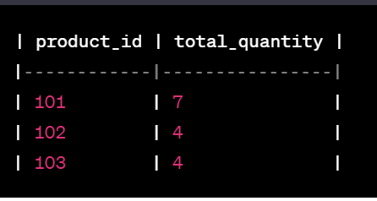

**EXAMPLE 2:**

**Sales Table:**

CREATE TABLE sales (

sale_id INT PRIMARY KEY,

salesperson_id INT,

product_id INT,

sale_amount DECIMAL(10, 2),

sale_date DATE

);

INSERT INTO sales (sale_id, salesperson_id, product_id, sale_amount, sale_date)

VALUES

(1, 101, 201, 150.50, '2024-01-01'),

(2, 102, 202, 75.20, '2024-01-01'),

(3, 101, 201, 200.00, '2024-01-02'),

(4, 103, 203, 120.75, '2024-01-02'),

(5, 102, 202, 50.00, '2024-01-03');

Group By Query:

-- Example: Grouping sales by salesperson_id and calculating the total sale amount

SELECT salesperson_id, SUM(sale_amount) AS total_sales_amount

FROM sales

GROUP BY salesperson_id;

Output:

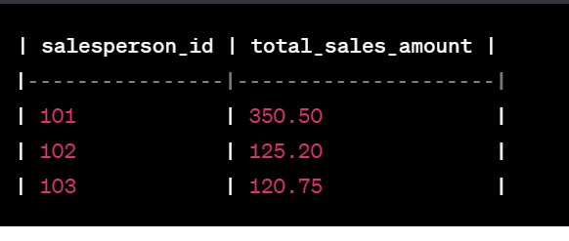

he SQL GROUP BY clause returns the aggregated value applying the functions on the columns of the table. The above screenshot shows that the result is returned grouped by CatID where no. of BookName present in those CatID is fetched.

**4. SQL HAVING Clause**

Actually, this clause is introduced to apply functions in the query with the WHERE clause. In SQL, the HAVING clause was added because the WHERE clause could not be applied with aggregate functions.

**Query:**

**SELECT Column FROM Table WHERE condition GROUP BY Column HAVING condition [ORDER BY Column];**

SELECT COUNT (CatID), Lang From Books GROUP BY Lang HAVING COUNT(CATID) <3

**Output:**



Here the result table is returned where the columns are grouped by Lang and no. of rows is restricted by the HAVING clause by providing a condition that CatID should be less than 3.

**5. SQL LIMIT Clause**

The LIMIT clause is used to determine the number of record rows to be shown in the result. This LIMIT clause is used with SELECT statement specially implemented on large tables with many records.

**MySQL Query:**

SELECT ColumnName(s) FROM TableName WHERE condition LIMIT no;

For example, we can explain this clause by these SQL statements where we can return the rows using LIMIT Clause with SELECT and WHERE for different database platforms:

EXAMPLE:

SELECT * FROM Books LIMIT 3;

Output:

